TUTORIAL PLAN
Unit: HPE 2203: Physical Performance Laboratory 1 Topic: TOUCH Week: 1
*** Use of grids and set up of markers for efficient transitions ***

Warm Up Activity #1

STUCK IN THE MUD
Duration | 10-15 minutes
Equipment | 1 ball per 2 participants
Area Size | Create a grid using cones to comfortably fit all your students
Instructions | - Variation of chasey or ‘IT’  - Students run around within designated area, half the students have balls, other half don’t.  - 2 students are ‘IT’ and attempt to tag other students.  - When students tagged they must stop immediately and become stuck in mud with feet apart.  - To be freed from the mud a student must have a ball rolled between their legs.  - If a student with a ball is tagged they stand feet in mud with ball above head it cant be taken.  - When ball is on floor any student can pick it up.
Variation and progression | - Pass between the 2 students – single or double
Teachable moment | Energy and enthusiasm  Using and defending space
Organisation

Set up rectangle to begin with extra markers on one side ready for skill development section

Warm Up Activity #2

REACT & CATCH
Duration | 5 minutes
Equipment | 1 ball per 2 participants
Area Size | Create a grid using cones to comfortably fit all your students
Instructions | - Student stand with ball on their head, hands on the buttock  - Drops head forward moves hands to catch ball behind back
Variation and progression | Catch behind back
Teachable moment | Focus and concentration  Peer teaching  Fundamental movement skills
Organisation: | Free Space with rectangle

GRID SET UP FOR CLASS
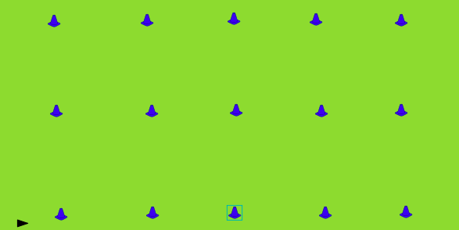
Activity #1

TRIANGLE PASSING
Duration | 5-10mins
Equipment | Groups of 3  1 ball between 3
Area Size | 5m x 5m grid
Instructions | - Students form a triangle in grid  - Passing ball around triangle using correct technique
Variation and progression | - Move to square  - Change of direction  - Change of length of pass  - Add competition
Teachable moment
Organisation:  Use small square grid 5m x 5m | Student select grid  Student establish a triangle  Teacher moves around and through grid

Activity #2

2 on 1 KEEPY OFF
Duration | 5-10mins
Equipment | Groups of 3  1 ball between 3
Area Size | 5m x 5m grid
Instructions | - Students work in pairs to move ball around in side grid  - Keep ball away from the defender  - Change positions if pass not completed  - Correct passing technique only
Variation and progression | ?? Tag of player with ball
Teachable moment | Creating Space  Decision making
Organisation:  Use small square grid 5m x 5m | Student select grid  Student establish a triangle  Teacher moves around and through grid

Activity #3

2 on 1 touchdown from loop
Duration | 10mins
Equipment | Groups of 3  1 ball per group
Area Size | 10m x 5m
Instructions | - 2 offensive players, 1 defensive player (rotate)  - 2 offensive players start on end line of grid  - 1 defensive player starts in centre of grid  - Offense players objective is to score a try, they can either pass or run through depending on their decision  - Defence attempts to tag player with ball or intercept pass
Variation and progression | Add in touch and play offside rule
Teachable moment | Decision making  Spacing
Organisation: | Use 2 vertical grids together  Leave space between grids for next drill

Activity #4

2 on 1 touchdown from loop
Duration | 10mins
Equipment | Groups of 3  1 ball per group
Area Size | 10m x 5m
Instructions | - 2 offensive players, 1 defensive player (rotate)  - 2 offensive players start mid way on right marker  - 1 defensive player starts mid way on left marker  - Offensive players run 1 way, defensive players run opposite direction around marker at end of playing area  - Offense players objective is to score a try, they can either pass or run through depending on their decision  - Defence attempts to tag player with ball or intercept pass
Variation and progression | Add in touch and play offside rule
Teachable moment | Decision making  Spacing
Organisation: | Use 2 vertical grids together  Leave space between grids for safety

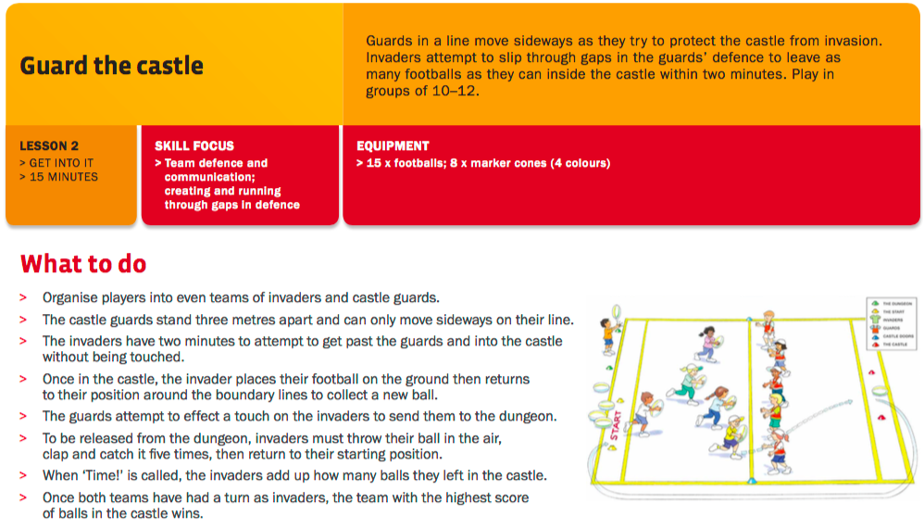
From (http://touchfootball.com.au/fileadmin/user_upload/Download_Documents/2015/Play_for_Life_-_Touch_Football.pdf)

End Game

Guard the Castle
Duration | 15-20 minutes
Equipment | Balls  Bibs
Area Size | Extend grids to make 2 fields  Can make a mirror image to cater for large class
Instructions | - See above
Variation and progression | After guard makes the touch they need to touch back line – creates space along guard line
Teachable moment | Making space  Acceleration and speed  Agility
Organisation: | Use of grids still – may need to extend or use rectangle and make a mirror image

Additional Notes
__________________________________________
__________________________________________
__________________________________________
__________________________________________
__________________________________________
__________________________________________
__________________________________________
__________________________________________
__________________________________________

__________________________________________
__________________________________________
__________________________________________
__________________________________________
__________________________________________
__________________________________________
__________________________________________
__________________________________________
__________________________________________

__________________________________________
__________________________________________
__________________________________________
__________________________________________
__________________________________________
__________________________________________
__________________________________________
__________________________________________
__________________________________________

Additional Notes
__________________________________________
__________________________________________
__________________________________________
__________________________________________
__________________________________________
__________________________________________
__________________________________________
__________________________________________
__________________________________________

__________________________________________
__________________________________________
__________________________________________
__________________________________________
__________________________________________
__________________________________________
__________________________________________
__________________________________________
__________________________________________

__________________________________________
__________________________________________
__________________________________________
__________________________________________
__________________________________________
__________________________________________
__________________________________________
__________________________________________
__________________________________________

