TUTORIAL PLAN
Unit: HPE 2203: Physical Performance Laboratory 1 Topic: TOUCH Week: 2
*** Use of grids and set up of markers for efficient transitions ***

Warm Up Activity #1

SCOOP TAG
Duration | 10 minutes
Equipment | 1 ball except 3 participants
Area Size | Create a grid using cones to comfortably fit all your students
Instructions | - Variation of chasey or ‘IT’  - Select 3 players to start as taggers  - All other players carry and run with ball evading taggers  - Taggers tag players who then perform a roll ball  - Tagger picks up ball and runs around area, can not re-tag tagger
Variation and progression | - Add in tap for tagger
Teachable moment | Energy and enthusiasm  Using and defending space
Organisation

Set up rectangle to begin with extra markers on one side ready for skill development section

Warm Up Activity #2

STAGGERED PASSING DRILL
Duration | 5 minutes
Equipment | 1 ball per group of 4
Area Size | Create a grid as below using cones to comfortably fit all your students
Instructions | - Ball to be passed along line as students run up and around markers  - On way back students form a staggered line  - Emphasis on running onto the ball
Variation and progression | Catch behind back
Teachable moment | Moving with ball  Passing on the run  Moving onto the ball
Organisation: | 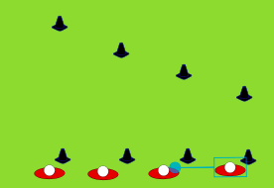

GRID SET UP FOR CLASS
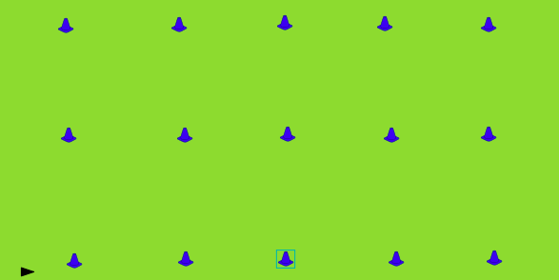
Activity #1

ROLL BALL into TRY
Duration | 5-10mins
Equipment | Pairs  1 ball in pair
Area Size | 5m x 10m grid
Instructions | - Students work in pairs  - Student 1 runs to 5m line and performs a roll ball  - Student 2 scoops and runs to 10m and scores a try  - Reverse on the way back, Student 2 roll ball, student 1 try.  - Have groups of 4 working in grid.
Variation and progression | Action of initiating the touch  Add in tap to start the drill
Teachable moment | Scoop and accelerate
Organisation:  Use small square grid 5m x 10m | Student select grid  Student establish a work station  Teacher moves around grids

Activity #2

DUMMY HALF
Duration | 5-10mins
Equipment | Groups of 3  1 ball between 3
Area Size | 5m x 10m grid
Instructions | - Students work in 3’s to move ball upfield  - Students 1 runs to 5m line and performs a roll ball, Student 2 acts as a dummy half, scoops ball (EXPLAIN DUMMY HALF RULE)  - Student 3 runs onto pass aiming at the 10m line  - Student 3 performs roll ball at 10m line, Student 2 runs into dummy half an passes back to student 1
Variation and progression | Action of initiating the touch  Add in tap to start the drill
Teachable moment | Catching the ball at speed  Flat passes off the scoop
Organisation:  Use small square grid 5m x 10m | Student select grid  Student establish a work station  Teacher moves around grids

Activity #3

3 on 1 InitIating the Touch
Duration | 10mins
Equipment | Groups of 4  1 ball per group
Area Size | 15m x 5m
Instructions | - 3 offensive players, 1 defensive player (rotate)  - 3 offensive players start on end line of grid  - 1 defensive player starts at 5m line of grid  - Offense players objective is to initiate the touch and beat defender to the next 5 m line, use same movement as drill 2  - Defence attempts to tag player with ball and get back 5m  - OFFSIDE RULE
Variation and progression | Add in tap when defender caught offside
Teachable moment | Decision making  Spacing
Organisation: | Extend vertical grid with extra marker or run horizontally  Leave space between grids for next drill

Activity #4

3 on 1 PICK AND POP
Duration | 10mins
Equipment | Groups of 4  1 ball per group
Area Size | 15m x 5m
Instructions | - 3 offensive players, 1 defensive player (rotate)  - 3 offensive players start on end line of grid  - 1 defensive player starts at 5m line of grid  - Offense players objective is to initiate the touch and beat defender to the next 5 m line, use same movement as drill 2  - Defence attempts to tag player with ball and get back 5m  - OFFSIDE RULE
Variation and progression | Add in tap when defender caught offside  Add in second pass and extra rotation
Teachable moment | Decision making  Spacing
Organisation: | Extend vertical grid with extra marker or run horizontally  Leave space between grids for next drill

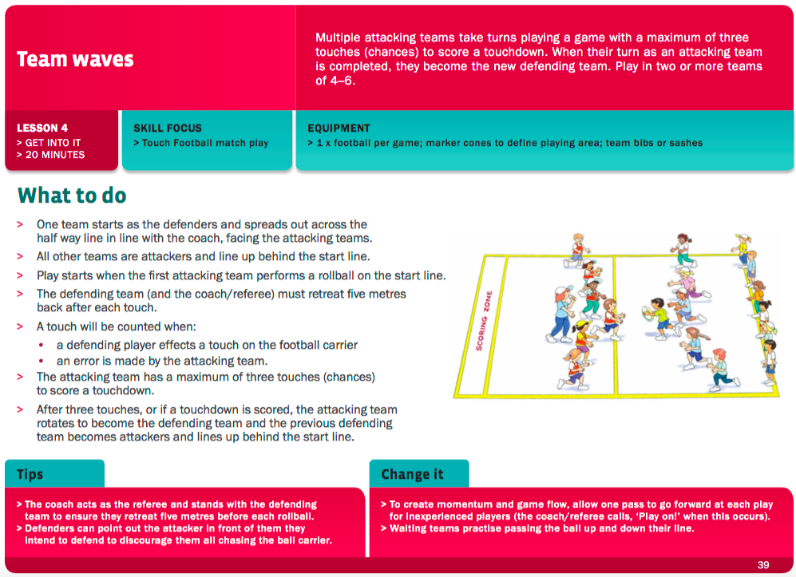
From (http://touchfootball.com.au/fileadmin/user_upload/Download_Documents/2015/Play_for_Life_-_Touch_Football.pdf)

End Game

TEAM WAVES
Duration | 15-20 minutes
Equipment | Teams of 4
Area Size | Extend grids into larger fields  Can make a mirror image to cater for large class
Instructions | - See above
Variation and progression | Start with tap
Teachable moment | Making space  Acceleration and speed  Agility
Organisation: | Use of grids still – may need to extend or use rectangle and make a mirror image

Additional Notes
__________________________________________
__________________________________________
__________________________________________
__________________________________________
__________________________________________
__________________________________________
__________________________________________
__________________________________________
__________________________________________

__________________________________________
__________________________________________
__________________________________________
__________________________________________
__________________________________________
__________________________________________
__________________________________________
__________________________________________
__________________________________________

__________________________________________
__________________________________________
__________________________________________
__________________________________________
__________________________________________
__________________________________________
__________________________________________
__________________________________________
__________________________________________

Additional Notes
__________________________________________
__________________________________________
__________________________________________
__________________________________________
__________________________________________
__________________________________________
__________________________________________
__________________________________________
__________________________________________

__________________________________________
__________________________________________
__________________________________________
__________________________________________
__________________________________________
__________________________________________
__________________________________________
__________________________________________
__________________________________________

__________________________________________
__________________________________________
__________________________________________
__________________________________________
__________________________________________
__________________________________________
__________________________________________
__________________________________________
__________________________________________

